City of Senoia 2024 Workshop
Meeting – May 24, 2024
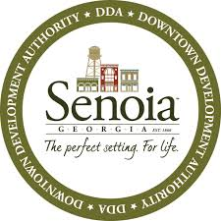

Friday:
8:30am – 11:30am
Topics
Bill Camp – Finance Presentation
Sewer Plant -
Water Plant – Support water withdraw request of 1.5 MGD from Keg Creek.
Barnes St. – Paving project
Baggarly St. – Paving / Stormwater Project
Freeman Sasser – Improvement quotes
Seavy Trail Project - Quotes
Downtown Parking – 123 Morgan St. recommendation
Courthouse Audio / Visual Upgrade - Quotes
SPLOST Projects – Update
Seavy Street Project – Quotes and Improvements

Information:
Stone Lodge- Marimac Lake Park
140 Pylant St.
Senoia, Ga 30276

