Summary
.  Mr. Deist is requesting a variance for his side setbacks for a placement of a garage. | 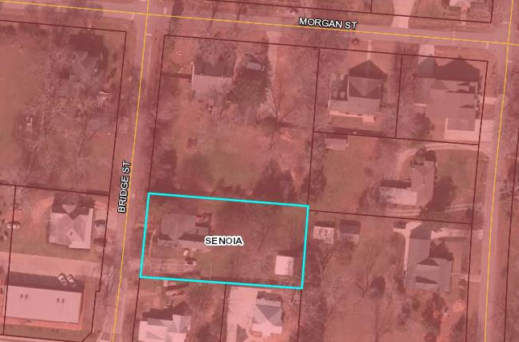

Zoning
Existing Zoning | Existing Land Use | Current Setbacks | Requested Setbacks
R-40 | Residential | Residential | The new lot will need to have water and sewer | .4995  .52
Staff Report
The City of Senoia received an application to grant a variance for the side setbacks to build a garage on the property. The applicant has a large tree on the property is trying to leave the tree intact. The location of the tree is hindering them from being able to build the garage to meet the required setbacks.

According to Article VIV of the City of Senoia Zoning Ordinance the Mayor and Council are authorize upon application a variance from the terms of the article, but only where by reason of exceptional narrowness, shallowness or shape of a specific piece of property, which, at the time of adoption of this article was a lot or plat of record; or where, by reason of exceptional topographic conditions or other extraordinary or exceptional conditions of a piece of property, or where by reason of other extraordinary or exceptional circumstances the strict application of the requirements of this article would result in practical difficulties of, or undue hardship upon, the owner of this property, provided that this relief may be granted without substantially impairing the intent and purpose of this article. In granting a variance, the city council may attach such conditions regarding the location, character and other features of the proposed building, structure or use as it may deem advisable so that the purpose of this article will be served, public safety and welfare secured and substantial justice done. However, the city council shall not be authorized to grant a use variance to permit a use in a district in which the use is prohibited.

