MARCH 25-26, 2022
MAYOR AND COUNCIL
RETREAT

ATTENDEES:
Council: Mayor Dub Pearman, Councilperson Maurice Grover, Councilperson Dale Reeder, Councilperson Tracy Brady, Councilperson Matt Foust
Staff: City Manager Harold Simmons, Special Projects Director Curtis Hindman, Public Works Director Jimmy Hall, Finance Director Kathy Storey, City Clerk and Human Resources Director Lynn Carter, Community Development Director Dina Rimi, Front Office Administrator Sharon Casey, Police Chief Jason Edens, PD Administrative Coordinator Alyson Leveillard, Code Enforcement Bo Cummings.
DAY ONE:
City Manager, Harold Simmons opened the meeting with the following PowerPoint presentation:
Past Retreat Topics and Update/Outcome:

- Residential Leak Insurance- Complete
- Alcohol Ordinance- Complete
- Park & Recreation- Waiting on shading to be installed in the two next month.
- Additional City Parking- Travis St. / Johnson St paving- Complete
- City Hall Expansion- Outside bathrooms should be complete by end of next month inside renovations will start immediately.
- Sewer Treatment Plant- On target
- Future Growth Potential

Future Growth Potential:
Estimated Potential Annexation over 6,883.62 acres
Future Development- East
Coweta Dunlap LLC- 1000
Woodbury Studio LLC -109.14
Ponders Living Trust- 45.4
Ellis Crooks- 84.19
Hwy 85 North Property – 74.55
Future Development- South
Neill & Hayes Property- 72.0
Hannah & Chappell Property- 26.8
Patel Family- 22.5
Vanderlooven Family-10.12

Future Development- West
141 South LLC -73
Bulloch Family- 3.0
Ray Family-15.32
McKnight Property – 902.42
Hamilton Property- 10.0
Morgan Property- 45.62
Pollard Property – 109.09
Butch Property – 295.0

Future Development- North
Lindsey Property – 38.24
Brent Property- 117.0
Stalls Road Church Property – 3,830.13

LOST Negotiations:

Senoia currently receives 3.13% of LOST revenue. LOST revenue currently makes up 24-25% of our budget. The county may be asking for a larger percentage in the future. Negotiations are July to October 2022.
Municipal Complex:
City is still in the design build phase. House bill 637 for our bonds for the complex. Please see diagrams below depicting Bond Projections.

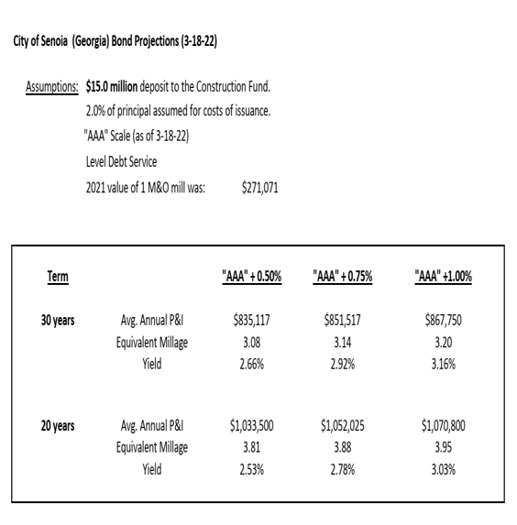
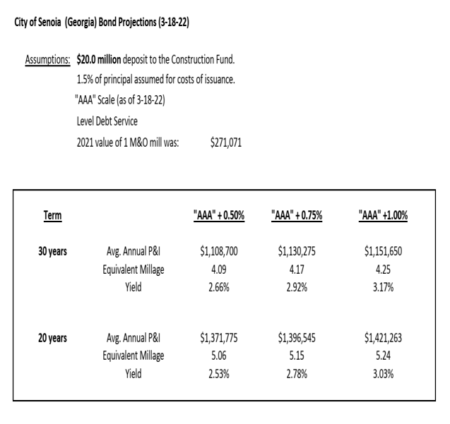
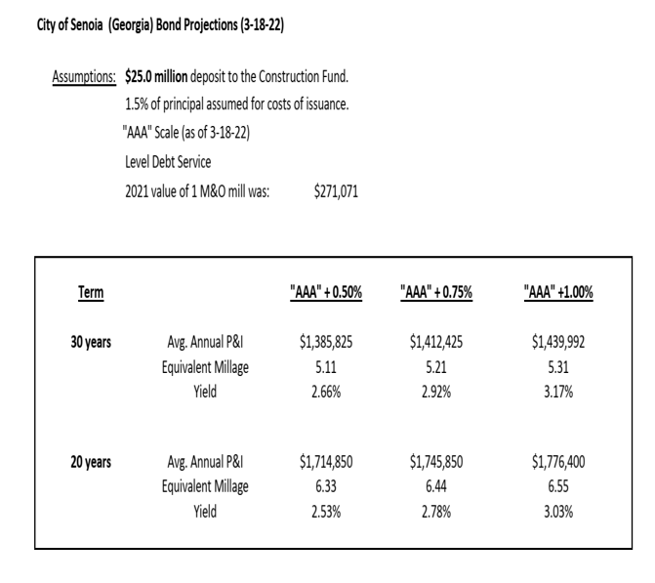

Winpak Property-To be sold in three phases:
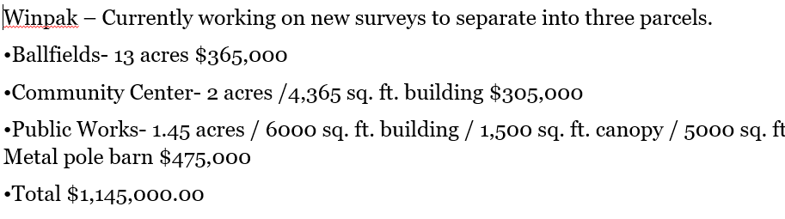
Tencate Property-We are negotiating purchase price:
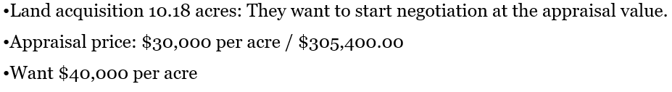
Councilperson Grover suggested possibly lowering the impact fees for their development in order to negotiate a lower price per acre. City Manager Simmons has authority to purchase for $305,400.
Search for Legal Council:
Due to Attorney Drew Whalen’s recent resignation, Harold Simmons has reached out to several municipal lawyers such as Scott Mayfield of Smith, Welch, Webb & White, Brad Sears of Sanders, Haugen & Sears, Ted Meeker of Sumner Meeker and Dennis Davenport of McNalley, Fox, Grant & Davenport.
10 Inch Water Main:
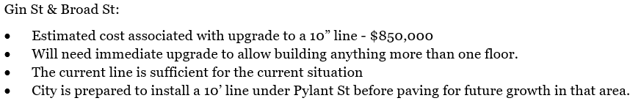
This project is projected to take place when the wall comes down.

ARPA Funds:
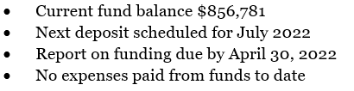
Mr. Simmons then proceeded to show Council necessary projects.
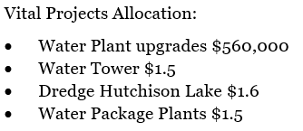
Mr. Simmons feels the water plant upgrades are the most important of the vital projects listed above.

Master Detention Pond:
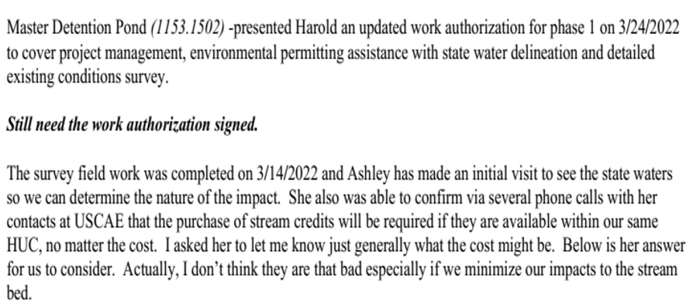
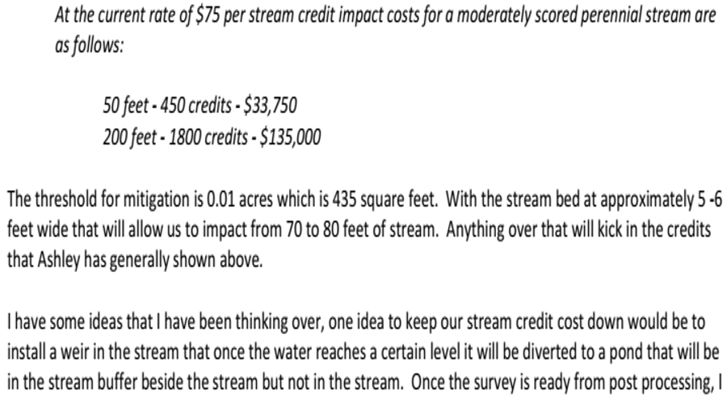
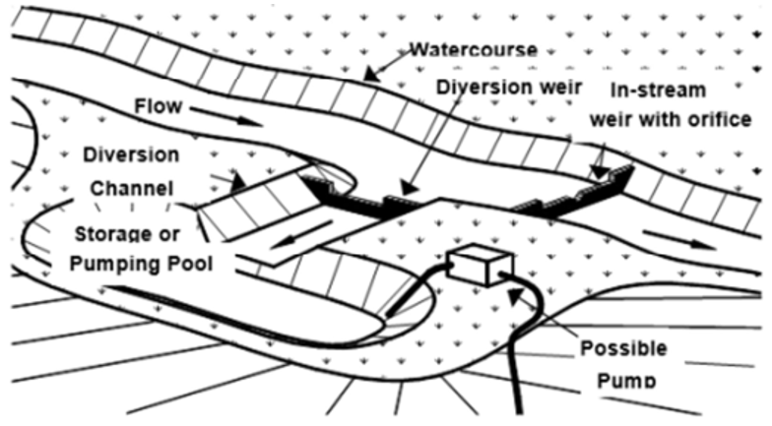
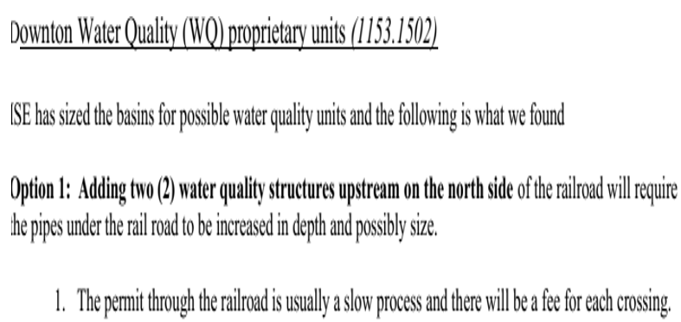
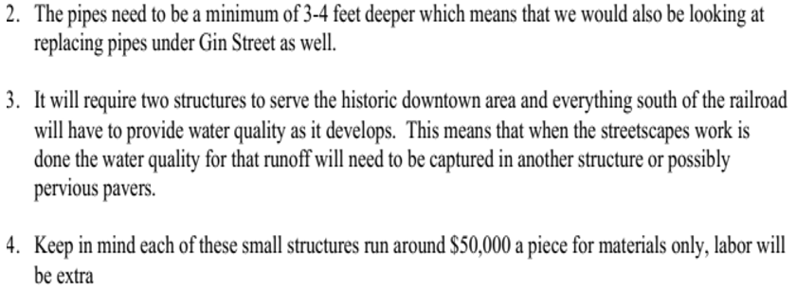
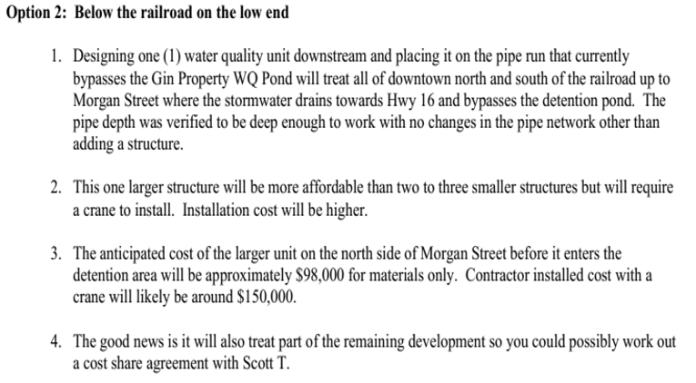
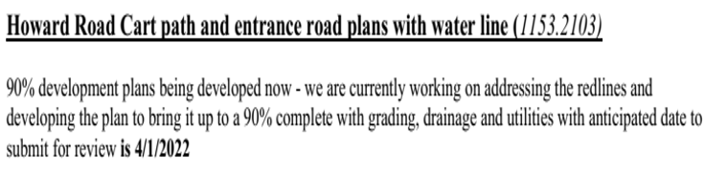
Welcome Center:
Council is to decide on whether to use the new train depot concept (1400 sq. ft.) or attempt to mimick the historic depot. Council will to forward to the Design Committee for opinions. The City will begin the project in 2-5 years. The City is currently working on infrastructure.
Benefits:
City Manager has requested Council for the following:
- to increase GMA Pension Fund from 2.0% to 2.5%;
- requesting a 5% match to the 457B plan;
- requesting a 5% raise; and
- Rule of 80 for the Police Department.

Close of Day One discussions.
DAY TWO:
Mayor Dub Pearman opened Day Two discussions.
LOST Negotiations:
June 16th negotiations with the county. There will be a quorum at the meeting, therefore, the meeting will need to be advertised. The City’s LOST revenue has exceeded expectations.
ARPA Status:
$856,000 in the account. Non-exempt entitlement unit. Must be spent by 2024. One more draw coming.
Priority:
Communication: Mayor and Council feel better communication is necessary between council, staff and public. Councilperson Grover prefers face to face discussions as emails get lost and go unanswered. Code Red is a good way to communicate with council as well as the public as messages can be directed to specific groups if necessary. Councilperson Reeder suggests a quick text and/or email. Mayor Pearman would like to be consulted and/or invited when meetings between council and others take place to discuss city business. Mayor further feels the need to filter all requests of staff through City Manager.
Councilperson Reeder would like to video/webcast the meetings and possibly place on website or have our own YouTube channel for broadcasting meetings.
Councilperson Foust has been in discussions with Allison Garrett’s son (AV Club) regarding videography of meetings. Councilperson Foust will help with set-up.
Councilperson Brady and Reeder feel the City website is very utilitarian. Councilperson Brady would like for Council and City Manager to meet with a local resident and business owner of a digital marketing company named Brian Brewer regarding updating our webpage. Council also feels it may be time for the City to hire someone for marketing and IT to promote the City of Senoia brand.
Future Legal Representation:
Council is good with the four attorneys presented at yesterday’s meeting. Tracy Brady would also like to put forward the law firm of Warner, Hooper & Ramsey.
Master Plan & Strategic Planning:
Community Development Director Rimi is scheduled to meet with Melissa Griffis regarding annexation of Lindsey property and Pollard Property. Council would like to see something in writing regarding the denial by the County before proceeding. Mayor would like to look at bringing on board a City Planner for future expansion. Director Rimi expressed that the City has utilized Three Rivers in the past for basic needs related to the Comp Plan. Possibly ask GMA who they suggest.
Walkability:
Pylant is to be repaved. The white lines are already in place thereby providing walkability now. City staff is working on other walkways. Special Projects Director Hindman is currently working on budget number for Cumberland Trail Project and working with Brent Scarborough on design. Councilperson Brady asked if one side of Pylant could be multi-use and the other side be golf cart parking instead of walking only on both sides. Must address the safety issues and maintenance of paint color.
Truck Route:
The City is still unable to enforce the truck route ordinance at this time. The City is working on widening the route before placing signage on route.

Workforce Housing:
Workforce housing by definition is the making/providing of affordable housing. In order to provide this housing it would be necessary to come up with an ordinance inclusive of a design element pleasing to council. Richard Ferry/Brent Scarborough is looking to put up townhomes behind Publix. Council agrees this would be a good topic for a workshop and planning and zoning.
Parks & Recreation:
Council would like to reestablish a parks & recreation committee. The City is in need of more shade at Seavy Street Park. The Spalshpad has been placed on hold. Council is looking forward to Phase 2 of the park.
Community Events:
Mayor and Council would like to be more accessible, present and approachable to residents. City Manager suggested a hotdog/meet and greet at Seavy Park possibly getting the police department and public works involved.
LCI Committee:
LCI decision is due May 11, 2022. The City needs to pick a consultant and would like to have support from local stake holders like business owners as well as utilizing downtown representatives and possibly HOA presidents in the decision making process. Council would like to complete streets with walkability, traffic/speed mitigation, tree planning and Pylant parking.
Day two discussions conclude.

