Memo

TO: Mayor and Council

FROM: Curtis Hindman, Interim Community Development Director
DATE: April 3, 2023

RE: 121 Baggarly Way – Two request and will require two separate motions
Rezone from R40 to RH
Variance request to reduce front setback from 15 feet to 7 feet.
Variance from lot size less than 0.5 acres.

Recommended approval to rezone from R40 to RH from Planning commission with a rear setback to match existing conditions.

Background

The applicant requests to amend the Zoning Map for the property located at 121 Baggarly Way from Residential (R-40) to Residential (RH). The applicant is also seeking to obtain a variance on the front setback to allow the proposed porch to be larger and located 7 feet from the right of way.

Below is an existing aerial showing the house as is and today it is approximately 12.9 feet from the steps to the right of way. This existing setback is non-conforming for both the R40 and RH zoning. The minimum front setback for R40 is 40 feet and for RH would be 15 feet. A variance to allow the porch to be only 7 feet from the right of way would represent a 46.7% variance.

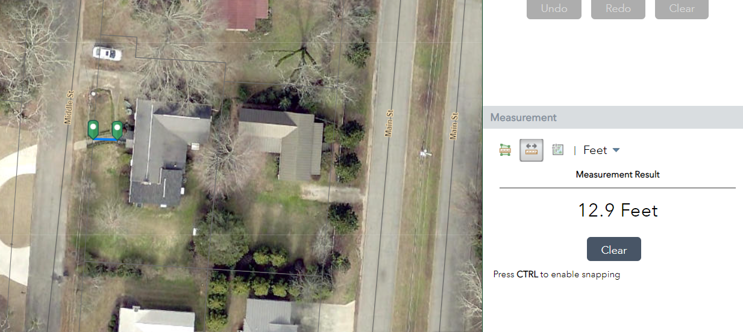

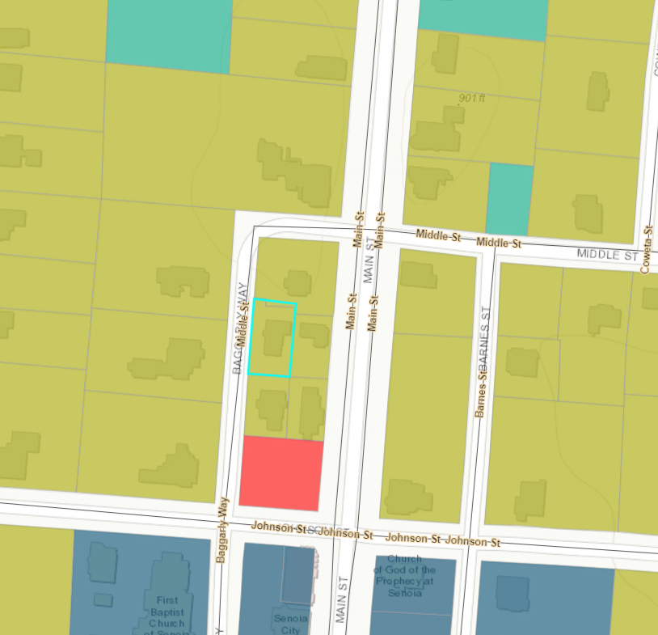
Zoned R40

According to the Comprehensive Plan amended and adopted in 2021 this property has been shown in the “Future Land Use Plan” as Single Family Residential.

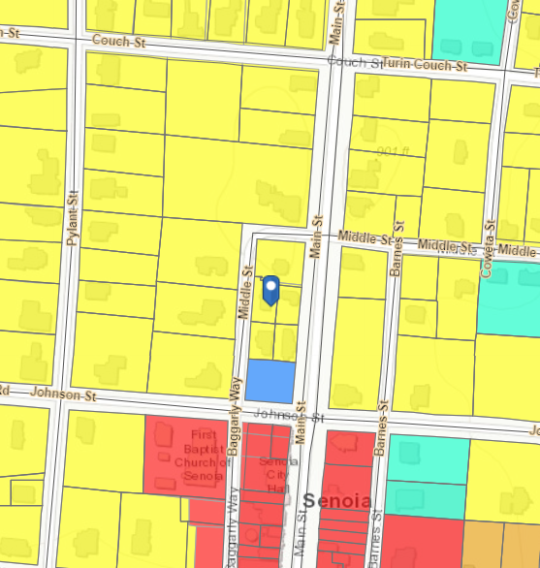

Land Use: Residential

Administrator's Report

In consideration of the requested zoning change, the Planning Commission should consider the zoning ordinance, section 74-46, which lists the following twelve standards governing the exercise of the zoning power of the City of Senoia.

- The existing land uses and zoning classification of nearby property.
The subject property is currently zoned R40 and located within the city limits and lies within the historic downtown overlay district.

- The suitability of the subject property for the zoned purpose.
The land is suitable for residential use as proposed. The current lot size however does not meet the requested RH minimum lot size and will need a variance to have less than 0.5 acres minimum lots size.
- The extent to which the property values of the subject property are diminished by the zoning restrictions.
There is no reduction in value of the land due to the existing or proposed residential zoning.
- The relative gain to the public, as compared to the hardship imposed upon the individual property owner.
The application represents no gain to the public. There is no recognized hardship for the property owner.
- Whether the subject property has a reasonable economic use as currently zoned.
The subject property does have a reasonable economic use for residential use as currently zoned.
- Whether the proposed zoning will be a use that is suitable in view of the use
and development of adjacent and nearby property.
The proposed zoning and use as residential are both suitable and similar to the existing uses adjacent to the subject property.

- Whether the zoning proposal will adversely affect the existing use or usability of adjacent or nearby property.
The zoning of RH will not negatively impact the adjacent properties existing use or usability. The setbacks in RH are smaller than in R40 but remain adequate for the intended use and lot size.
The ordinance allows a rear setback of zero and Planning Commission recommended the rear setback be set to match the existing condition.
- Whether the zoning proposal is in conformity with the policies and intent of the land use element of the Comprehensive Plan.
The future character map shows this property as Residential.
- Whether the zoning proposal will result in a use, which will or could cause excessive or burdensome use of existing streets, transportation facilities, utilities, or schools.
No excessive use or burden is recognized in this application.
- Whether there are other existing or changing conditions affecting the use and development of the property, which give supporting grounds for either approval or disapproval of the zoning proposal.
There is none.
- Whether the subject property contains jurisdictional wetlands of the United States. If so, the applicant will be required to document permit approval for the proposed development from the U.S. Army Corps of Engineers before any formal action can be taken on the zoning proposal.
There is none.
- Whether the subject property may be large enough to qualify as a Development of Regional Impact. If so, then an application for Review must be filed with the Regional Development Center.
The development is not big enough to qualify.

