June 3, 2024

To: Mayor and Council
RE: Staff Report – 309 Morgan Street (aka 7930 Wells Street) –Variance

The applicant has submitted a variance application to reduce lot size to .26 acres and a front setback encroachment of 1’- 1”.

Background:

Applicant resides at 291 Morgan Street and rents the home at 309 Morgan Street. He has submitted an application to Planning Commission requesting to amend zoning at 309 Morgan Street from Residential R40 to Residential RH.

Applicant has also requested to split the lot in the rear of the property at 309 Morgan Street. His intent is to adjoin the existing garage and concrete drive to his residence at 291 Morgan Street. This will reduce the lot size at 309 Morgan Street to 0.26 acres. His plan is to sell the home at 309 Morgan Street.

291 Morgan Street is shown in “yellow” on the following page, while 309 Morgan Street is shown in “orange”. Lot is currently non-conforming, approval for split will increase the non-conformity.

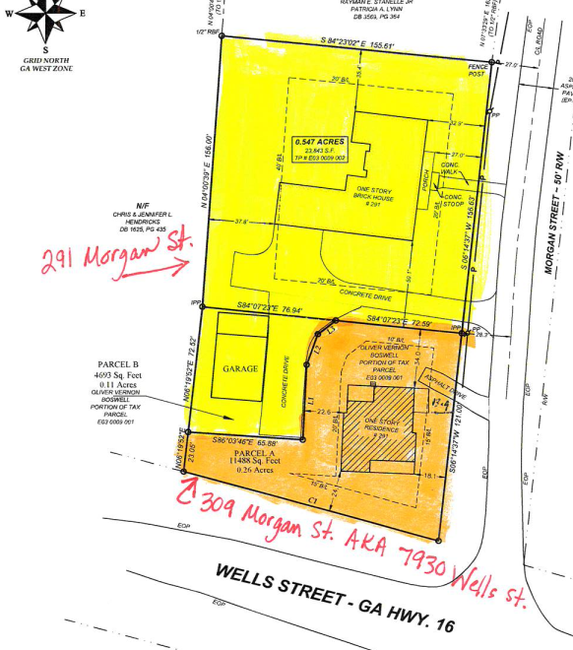

The primary structure at 309 Morgan Street is currently 13.9’ from the property line, therefore applicant is seeking a setback encroachment of 1’-1”.

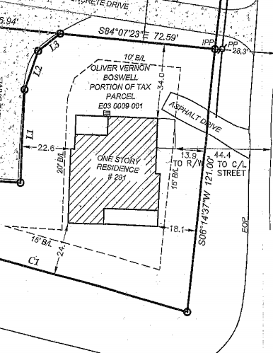

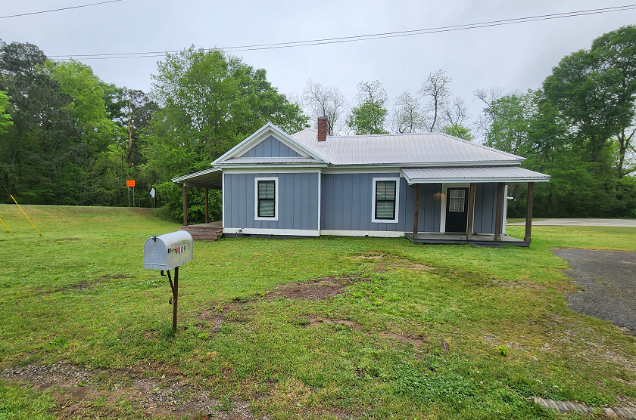

COMMENTS:
- Negative impacts are recognized by approving this variance because future land use for property is commercial.
- Letter of support from adjoining property owner at 322 Morgan Street

