To: Honorable Mayor Dub Pearman and Members of the City of Senoia Council

Harold Simmons, Township Manager

From: Amanda L. Jensen, AICP, CFM, Community Development Director

Date: July 29, 2024

Re: Keg Creek Phase 2B – Plat Amendment

The applicant has submitted a plat amendment application to shift the rear lot line of lot 108 fifteen (15) feet to provide a larger backyard.

Background:

Co-applicants are the developer, Keg Creek LLC, and builder, Dague Communities Inc. Lot 108 is known as 440 Werner Way and backs on HOA maintained open space that is approximately seventy (70) feet wide. There is another residential lot on the other side of the open space.

Applicants have requested to shift the rear lot line fifteen (15) feet to the northwest to increase the backyard of Lot 108. This would reduce the distance between backyards from approximately 70 feet to approximately 55 feet along this lot. This change will reduce the open space in this Phase from 12.57 acres to 12.55 acres, which meets City requirements. No zoning issues are created with this revision.

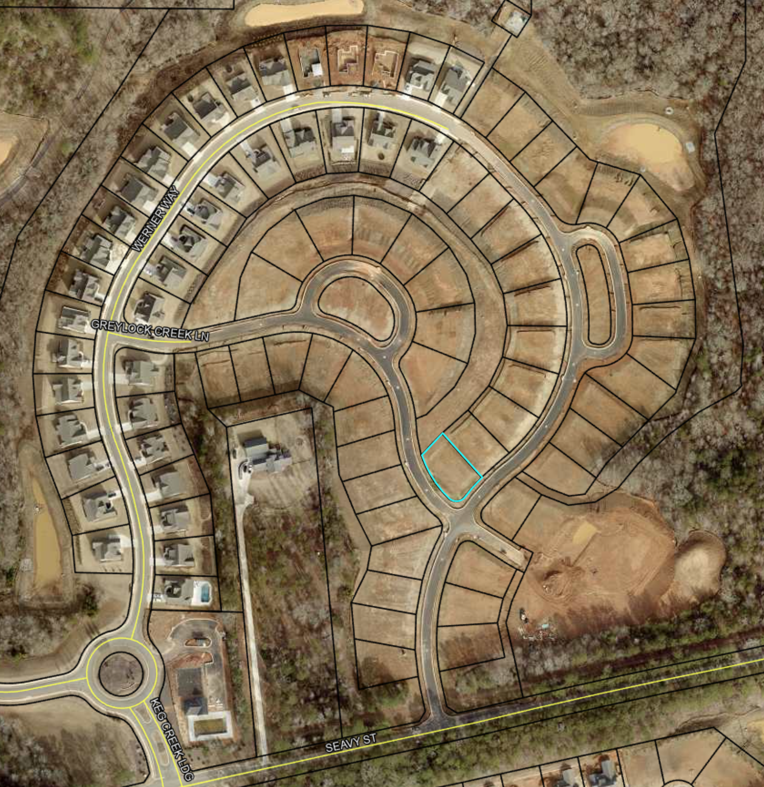

The parcel highlighted in blue is the parcel in question. The remainder of the lots will remain as originally platted and shown here.

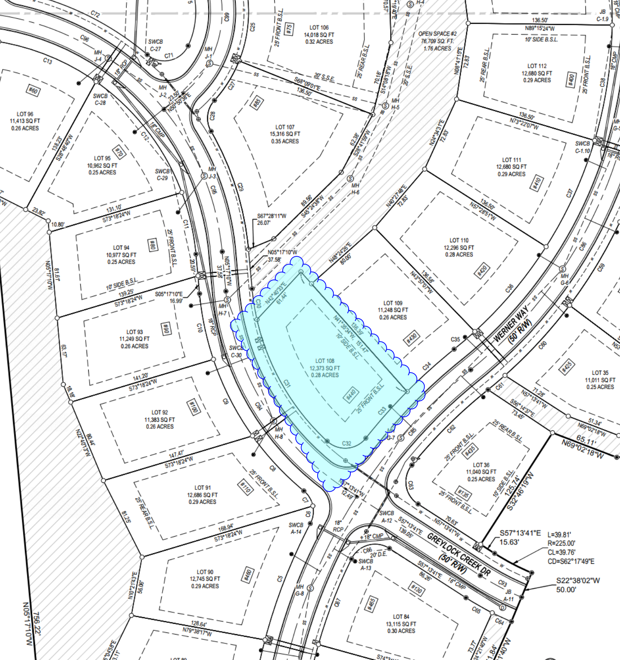

This demonstrates the proposed change on the plat amendment.

**COMMENTS:**

* No negative impacts are recognized by approving this plat amendment.
* Future land use for property is residential.