Staff Report City of Senoia Dina Rimi

Department of Community Development drimi@Senoia.com
Item | Variance | Location | Middle Street, Prop Tax ID: E02 0012 008
Planning Commission Date | N/A | Mayor and Council Date | July 20, 2020
Applicant | J. Dale | Purpose | To Build a Single Family Structure

Summary
The applicant, J. Dale is requesting to obtain a variance to be permitted to construct a single-family structure on her lot.  This property was subdivided and rezoned by the previous owner at the August 3, 2015 Mayor and Council meeting  A motion was approved for the subdividing with the condition that a single family home not be constructed on the lot. | 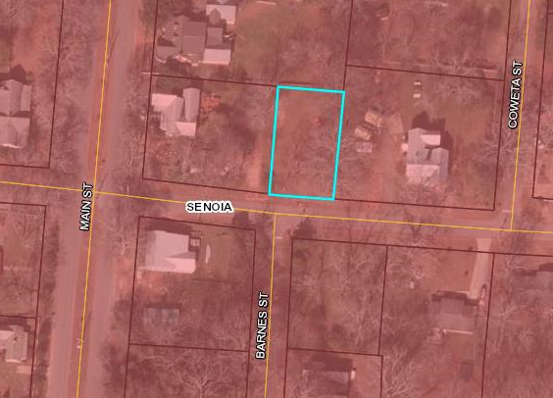

Zoning
Existing Zoning | Existing Land Use | Surrounding Zoning | Site Improvements | Size of Property
Historic Residential | Residential | R- 40 and HR | Will need to hook up to water and sewer | .17 acres
Setbacks | Front -15 Side -20 Rear -40
Min. Lot Width at Setback | 80 Ft
Minimum Sq. Ft | Average of adjacent properties
Staff Comments
When the home is built if the builder is not able to meet the minimum requirements for the lot the property owner will need to obtain an approved variance.

