Sec. 70-101. Fats, oils and grease/BOD ordinance.
(a) Purpose. Excessive amounts of fats, oils and grease, grit, sand and other solids or viscous materials can cause blockage and obstruction in the sanitary sewer system, causing untreated wastewater to overflow into the environment. Much of the waste material that has the potential to cause blockage or obstruction originates from commercial facilities, such as food preparation and vehicle maintenance facilities.
This regulation sets forth minimum and uniform requirements for the treatment and disposal of commercial/residential waste into the city's sanitary sewer system, and the transportation and ultimate disposal of commercial/residential waste sludge and byproducts.
The objective of this regulation is:
(1) To reduce sanitary sewer overflows (SSOs) caused by fats, oil, and grease (FOG) in the City of Senoia sewer collection system;
(2) To minimize the discharge of pollutants associated with commercial waste discharged into the sanitary sewer system that may interfere with normal operation of the system;
(3) To assure that the sludge and byproducts removed from commercial waste treatment systems are transported and disposed of in accordance with chapter 391-3-6-.24 of the Rules and regulations of The State of Georgia, Department of Natural Resources and Environmental Protection Division;
(4) To provide for the requirement and permitting of grease interceptors in food service establishments;
(5) To provide for the mandatory cleaning of grease traps;
(6) To prohibit the use of certain additives in grease traps;
(7) To provide for the reduction of FOG/BOD into the city’s sewer system
(8) To prohibit the discharge of certain wastes into the city's sanitary sewer system;
(9) To provide for the collection of a fee for the cleaning of trap waste when performed by the city;
(10) To provide for penalties in the event of permit violations; and
(11) To provide for the enforcement of this ordinance.
(b) Definitions. Unless otherwise expressly stated or the context clearly indicates a different intention, the following terms shall, for the purposes of this regulation, have the meanings indicated in this section:
(1) "Commercial facilities" means a facility constructed and intended to produce commercial, domestic, or industrial wastewaters, including facilities intended to collect, transport, and treat storm water runoff.
(2) "Commercial waste" means:
a. Non-toxic, non-hazardous liquid wastewater from non-residential facilities and multifamily structures;
b. Grease interceptor contents generated by a commercial food operation or institutional food preparation facility, including, without limitation, fats, grease, and food scraps; or
c. Any oil-waste residue produced from vehicle maintenance or washing that discharges to an oil-water separator or sand trap.
(3) "Commercial waste discharge permit" means a wastewater discharge permit issued to commercial facilities subject to this regulation.
(4) "Domestic wastewater" means wastewater from sanitary fixtures such as toilets and urinals.
(5) "FOG management program" means a comprehensive program designed to reduce and/or control the discharge of fats, oil, and grease into the City of Senoia Sanitary Sewer System by educating and regulating food service establishments and car washing facilities located in City of Senoia.
(6) "Food service establishment" means any person or entity who prepares and/or packages food or beverages for sale or consumption, on or off site, with the exception of private residences as long as the private residence is not used to prepare or package food or beverage for sale. "Food service establishment" includes but is not limited to food courts, food manufacturers, food packagers, restaurants, catering services, bars, taverns, cafeterias, cafes, fast food outlets, mobile food vehicles, wing trailers, diners, grocery stores, bakeries, coffee shops, ice cream shops, loungers, hospitals, hotels, nursing homes, churches, schools, daycare centers, and any other food service establishment not listed above, either fixed or mobile, as are or may hereafter be recognized by the city, the county health department and/or the state department of agriculture.
(7) "Grease" means a material composed primarily of fats, oil, and grease from animal or vegetable sources. The terms fats, oil, and grease shall be deemed as grease by definition. Grease may also include petroleum-based products.
(8) "Hauler or transporter" means one who transfers waste from the site of a user to an approved site for disposal or treatment. The hauler is responsible for assuring that all federal, state and local regulations are followed regarding waste transport and disposal.
(9) "Hazardous waste" means any solid waste that has been defined as a hazardous waste in regulations promulgated by the Board of the Georgia Department of Natural Resources, chapter 391-3-11.
(10) "Interceptor" or "separator" or "trap" means a device constructed so as to separate, trap, and hold fats, oils, greases, and/or sand and grit substances from the wastewater discharged by a facility to prevent these substances from entering the sanitary sewer system.
(11) "Originator" means the owner or operator of the grease of FOG interceptor, grit trap, oil-water separator, or sand trap from which commercial wastes are removed.
(12) "Under-sink" or "inline grease trap" means a device placed under, or in close proximity to sinks or other facilities likely to discharge grease in an attempt to separate, trap or hold, oil and grease preventing their entry into the sanitary sewer system.
(13) "User" means a source of discharge to the sanitary sewer of the City of Senoia Sanitary Sewer System.
(14) "Waste" or "wastewater" means the liquid and water-carried domestic or industrial wastes from dwellings, commercial establishments, industrial facilities, and institutions, whether treated or untreated, contributing to the sanitary sewer.
(15) “Hydromechanical grease interceptors” means a device that treats kitchen wastewater from food service establishments using gravity separation aided by vented flow control.
(16) “Wet Waste Interceptor” means a device that uses a physical filter to remove most of the organic solid matter before it enters the grease trap.
(17) “Garbage Disposal” means an electrically operated device designed to grind up food waste.
(c) Abbreviations. The following abbreviations, when used in this regulation, shall have the designated meanings:
(1) FOG Fats, Oil, and Grease.
(2) EPD Environmental Protection Division of the Department of Natural Resources, State of Georgia.
(3) SWPCP The City of Senoia Water Pollution Control Plant.
(4) BOD Biochemical Oxygen Demand.
(5) CFR Code of Federal Regulations.
(6) COD Chemical Oxygen Demand.
(7) EPA U.S. Environmental Protection Agency.
(8) FSE Food Service Establishment.
(9) gpd gallons per day.
(10) mg/l milligrams per liter.
(11) NPDES National Pollutant Discharge Elimination System.
(12) POTW Publicly Owned Treatment Works.
(13) RCRA Resource Conservation and Recovery Act.
(14) SIC Standard Industrial Classification.
(15) TSS Total Suspended Solids.
(16) HGI Hydromechanical grease interceptors
(d) Administration. Except as otherwise provided herein, the City of Senoia City Manager, or his designee shall administer, implement, and enforce the provisions of this regulation. Any powers granted to or duties imposed upon the Senoia City Manager or his designee may be delegated to other Senoia Water Pollution Control Plant (SWPCP) personnel and/or staff.
(e) Coverage and exclusions.
(1) This regulation applies to any facility that generates commercial wastes, to any person who removes commercial wastes, to any person who processes commercial wastes, and to any person who accepts commercial wastes for final disposal.
(2) This regulation applies to all persons and entities subject to its regulation, both within and without the geographical and political boundaries of the City of Senoia, who discharge to the Senoia Wastewater Pollution Control Plant.
General Criteria
(a) Installation requirements for new food service facilities. All proposed or newly remodeled food service facilities who discharge to the City of Senoia Wastewater Pollution Control Plant shall be required to install an approved, properly operated and maintained grease interceptor. All interceptor units shall be installed outdoors of the food service facility building unless the user can demonstrate to The City of Senoia that an outdoor interceptor would not be feasible. All interceptor units shall be of the type and capacity approved by the City of Senoia.
(b) New facilities. On or after the effective date of this regulation, food service facilities which are newly proposed or constructed, or existing facilities which will be expanded or renovated to include a food service facility, where such facility previously did not exist, shall be required to install, operate and maintain a grease interceptor according to the requirements contained in this regulation and must be approved by City of Senoia prior to connection to the sewage collection system.
(1) All grease interceptors required in this section shall have a capacity of 15 gallons per seat, except that no single grease trap shall be smaller than 1,500 gallons nor larger than 3,000 gallons. City of Senoia may, in its sole discretion, approve multiple grease traps. All grease traps and interceptors shall be certified at a minimum of 90% efficiency; they must be certified to ASME A112.14.3 or PDIG101 standards at the HGI’s specified maximum flow rate.
(2) All grease interceptors/traps must be permitted through City of Senoia. Grease interceptor users must abide by the conditions set forth by the permit. Permit Violations may result in loss of permit, disruption of water and sewer services and/or fines.
(3) All grease interceptors shall be of a type and capacity approved by City of Senoia and shall be located as to be readily and easily accessible for cleaning and inspection. Grease interceptors shall be constructed of impervious materials capable of withstanding abrupt and extreme changes in temperature. They shall be of substantial construction, and shall be watertight and equipped with easily removable covers which, when bolted in place, shall be gastight and watertight. Under-sink manual grease traps shall not be permitted. unless approved by City of Senoia.
(c) New Residential Developments: In efforts to reduce BOD entering the City’s Sewer System and maintain BOD levels leaving the Sewer Plant (effluent) within state guidelines, new residential development shall be prohibited to include garbage disposals.
(d) Requirements for existing food service facilities.
Existing facilities. For the purposes of sizing and installation of grease interceptors, all food service facilities existing within the city prior to the effective date of this regulation shall be permitted to operate and maintain existing grease interceptors or grease traps provided their grease interceptors or grease traps are in efficient operating condition operating at the 90% efficiency set by the City.
Any changes to the plumbing that falls under the reach of this FOG ordinance must be submitted as engineered drawings to the City of Senoia for plan review.
On or after the effective date of this regulation, the city may require an existing food service facility to install, operate and maintain a new grease interceptor or trap that complies with the requirements of this regulation or to modify or repair any noncompliant plumbing or existing interceptor or trap within 90 days of written notification by the city when any one or more of the following conditions exist.
All existing food service facilities inside the City of Senoia Wastewater Service area are expected to conduct their operations in such a manner that grease is captured on the user's premises and then properly disposed. Existing food service facilities will be handled under the City of Senoia's Grease Management Program in the following manner:
(1) The City of Senoia will may periodically inspect each food service facility on an as-needed basis to assure that each facility is complying with the intent of the grease control program. The as needed inspection shall be determined by the City of Senoia.
(2) Each food service facility located in the vicinity of any problem areas will be inspected. The facilities' grease control practices and the adequacy of their grease control interceptor/equipment will be assessed. Maintenance records will also be reviewed.
(3) All food service establishments, including, without limitation, restaurants of all types, catering facilities, hospital cafeterias, school and business cafeterias, and convalescent homes, which discharge to the City of Senoia's sewage collection system shall install, operate, and maintain a sufficiently sized grease trap (as approved by City of Senoia Engineering Department and described in section 5.1.C of the F.O.G. Regulation) necessary to achieve compliance with the requirements set forth in this article.
(4) The facility is found to be contributing fats, oils and grease in quantities sufficient to cause sewer line stoppages or necessitate increased maintenance on the wastewater collection system.
(5) The facility does not have a grease interceptor or trap.
(6) The facility has an undersized, irreparable or defective grease interceptor or trap.
(7) Remodeling of the food preparation or kitchen waste plumbing system is performed which requires a plumbing permit to be issued by City of Senoia.
(8) The existing facility is sold or undergoes a change of ownership.
(9) The existing facility does not have plumbing connections to a grease interceptor or trap in compliance with the requirement of the regulation.
(10) Food service establishments located in existing buildings or using existing grease interceptors may apply for a hardship variance from City of Senoia to use under-sink automatic grease traps. Such variances may be granted when, in the sole discretion of City of Senoia, the establishment's premises are incapable of supporting a grease trap which otherwise meets the necessary permit requirements, and the use of automatic grease traps will not affect the efficient handling and elimination of liquid wastes containing grease, oils, sand, or other harmful ingredients.
(11) The Food Service Establishment changes their menu offerings or equipment in such a manner that increases their FOG production.
(e) Responsibility.
(1) Administration. City of Senoia, through its employees and/or duly authorized agents, shall be responsible for the scheduling for all inspections of grease interceptors and grease traps.
(2) The food service facility shall be responsible for installation, repair, pumping, and cleaning, of grease interceptors and/ or traps if applicable. Pumping and cleaning shall include the complete removal of all contents, including floating materials, wastewater, and bottom sludge, and solids from the interceptor.
(3) The food service facility shall cause all grease interceptors and/or approved traps which are in active use to be pumped out completely and the wastes be removed from the property at least once during every three-month period, or more frequently if deemed necessary by City of Senoia. Unless the City of Senoia determines that the Users capacity is less than 10% after the 90 days has passed, then the City shall extend in writing the 90-day limit. Users shall notify City of Senoia if a grease trap has exceeded its total capacity or is in imminent danger of reaching such total capacity.
(4) Waste haulers. Waste haulers must have written permission from City of Senoia in order to return any gray water back into the grease interceptor. This permission will be granted on a case by case basis and will depend upon the methods by which the solids and grease are separated in order to assure that clear water is the only material returned to the grease interceptor. City employees and agents will observe all company safety rules while on private properties. Waste Haulers shall not reintroduce any gray water back into the trap/interceptor or the system.
(5) Disposal. Wastes removed from each grease interceptor shall be disposed of at a facility permitted by the State of Georgia Environmental Protection Department to receive such wastes or at a location designated by City of Senoia for such purposes. Neither grease nor solid materials removed from interceptors shall be returned to any grease interceptor, private sewer line or to any portion of the City of Senoia collection system or treatment plant. without prior written permission from a City of Senoia official.
(6) Spill reporting. Any accident, spill, or other discharge of grease or gray water which occurs within the city shall be reported to City of Senoia by the grease hauler as soon as possible but not longer than 24 hours after the incident. The grease hauler shall comply with all procedures contained in federal, state and local regulations. The grease hauler shall be responsible for all clean-up procedures and costs.
(7) Manifests. Grease haulers shall retain and make available for inspection and copying, all records related to grease interceptor pumping and grease disposal from businesses connected to City of Senoia of Senoia's wastewater collection service system. These records shall remain available for a period of at least three years. City of Senoia may require additional record keeping and reporting, as necessary, to ensure compliance with the terms of this chapter.
(8) Following the inspections, the City of Senoia will may send written notice to the inspected food service facilities containing a summary of the policy requirements and the results of the inspection. The inspections will typically result in one of the following actions:
a. Facilities equipped with an appropriate and adequately sized grease interceptor who are meeting the intent of the grease management program through effective grease control practices will be commended for their compliance.
a. After notice and an opportunity to be heard, facilities not in compliance shall be required to develop and submit to the City of Senoia a proposed plan designed to achieve compliance through improved housekeeping and/or increased maintenance and pumping of the existing grease interceptor/equipment.
b. Facilities that are not successful in achieving compliance with the intent of the grease management program through improved housekeeping and increased maintenance and pumping of the existing grease interceptor/equipment will be required to install the necessary interceptor/equipment to bring the facility into compliance.
(f) Prohibited discharges. Domestic wastewater shall not be discharged to the grease interceptor. unless specifically approved, in writing, by the City of Senoia.
(g) Waste minimization plan. Food service facilities shall develop and implement a waste minimization plan pertaining to the disposal of grease, oils, and food particles.
(h) Floor drains. Only floor drains which discharge or have the potential to discharge grease shall be connected to a grease interceptor.
(i) Location. Each grease interceptor shall be installed and connected so that it is easily accessible for inspection, cleaning, and removal of the intercepted grease at any time. Grease interceptors required under this ordinance shall be installed outdoors of the food service facility, and upstream from the domestic wastewater drain line(s). A grease interceptor may not be installed inside any part of a building unless approved in writing by the City of Senoia. The user bears the burden of demonstrating that an outdoor grease interceptor is not feasible.
(j) Best Management Practices. It is the requirement of the FSE’s management to provide and have posted Best Management Practices (BMP) in an effort to reduce the amount of grease entering the system. Best Management Practices material can be requested from Public Works.
Design Criteria
(a) Construction of interceptors. Grease interceptors shall be constructed in accordance with the City of Senoia plumbing standards and outdoor units shall have a minimum of two compartments with fittings designed for grease retention. All alternative grease removal devices or technologies shall be subject to the written approval of the City of Senoia. Such approval shall be based on demonstrated removal efficiencies of the proposed technology of at least 90% removal efficiency.
(b) Access. Outdoor grease interceptors shall be provided with two manholes terminating one inch above finished grade with cast iron frame and cover. All grease interceptors shall be designed and installed to allow for complete access for inspection and maintenance of inner chamber(s) as well as viewing and sampling of wastewater discharged to the sanitary sewer. Interceptors shall not be located in heavily trafficked areas such as driving lanes of a parking lot that may interfere with inspection and maintenance capabilities. Access shall be installed to manufacturer’s specs for accessibility and proper cleaning. Interceptors shall not be located in heavily trafficked areas such as driving lanes of a parking lot that may interfere with inspection and maintenance capabilities. The covering(s) shall terminate to be level with the surrounding area.
(c) Load-bearing capacity. For Interceptors located in outside areas where additional weight loads may exist, the grease interceptor shall be designed to have adequate load-bearing capacity. (example: parking areas).
(d) Inlet and outlet piping. Wastewater discharging to the grease interceptor shall enter only through the inlet pipe of the interceptor. For Concrete Grease Interceptors the inlet pipe bottom tee branch shall extend one foot below liquid level. The outlet pipe bottom tee branch shall be submerged to 2/3 of the liquid depth. Each grease interceptor shall have only one inlet and one outlet pipe. Hydromechanical Grease Interceptors are to be installed in accordance to manufacturer’s specifications.
(e) Concerning strip malls and suites. In the cases where several facilities are connected as one building such as suites , each individual business shall be required to have its own trap/interceptor. If this is not possible it is the building owner’s sole responsibility in reference to all cleanings, maintenance and fines procured by these businesses.
(f) 3-compartment sinks. Any 3-compartment sink in a FSE shall install a Wet Waste Interceptor, solid interceptor or similar properly sized for the sink per manufacturer’s specifications.
(g) Dish Washer/Dish Machine. It is to the discretion of the City of Senoia if the Dish Machine shall be connected to the Trap/Interceptor.
(h) Grease trap or interceptor sizing. According to the Uniform Plumbing Code (UPC), the difference between a grease trap and a grease interceptor is the flow rate of wastewater the device can handle. Grease traps have a flow rate of less than 50 gallons per minute, are smaller, and are usually found inside the kitchen, and can vary in size, from as small as a box to as large as a mini-fridge. The City of Senoia regulations do not allow any grease traps smaller than a 70-pound capacity.
Alternatively, grease interceptors have a flow rate of more than 50 gallons per minute, are much larger, and due to their size, they are installed underground and outside of the building.
Pre-determining accurate sizing of proposed grease traps and/or interceptors is an inaccurate science at best as flow amounts and grease production assessments are dependent on numerous factors that are difficult to define. To ensure standardization throughout the city, the City of Senoia regulations require a minimum interceptor size of no less than 1,500 gallons, and not to exceed a capacity of 3,000 gallons. Any additional capacity shall require the use of multiple interceptors. In addition, all indoor grease traps should hold a minimum of 70 pounds.
Still, it may be helpful to estimate approximate sizing prior to an installation, and various formulas have been developed for assessing sizing requirements. These formulas are discussed below and on the following page to assist with the planning process.

[Editorial Note: Remove this section entirely and replace with the section titled “Sizing and Selecting Hydromechanical Grease Interceptors (HGI)”]
(1) Grease traps for optimum efficiency. A grease trap requires regular maintenance. That means, periodically emptying and cleaning of the grease trap. Due to their smaller size, grease traps will generally require more cleaning than grease interceptors as they tend to fill-up rather quickly. Local inspectors will determine the frequency of cleaning and maintenance based on its performance, which in large part will be based on flow rates and/or grease production.
a. Under-sink grease trap requirements shall meet Plumbing and Drainage Institute Standard PDI-G101. Flow rates can be estimated using the chart below:
Type of Fixture | Flow Rate (gpm) | Grease Retention  Capacity (lbs)
Restaurant hand sink | 15 | 30
Pre-rinse sink | 15 | 30
Single-compartment sink | 20 | 40
Double-compartment sink | 25 | 50
Two double-compartment sinks | 35 | 70
Dishwasher up to 30 gallons | 15 | 30
Dishwasher up to 50 gallons | 25 | 50
Dishwasher up to 100 gallons | 40 | 80
Other fixture | Manufacturer peak | gpm X 2

(2) Grease interceptors. As stated, grease interceptors are designed for kitchens that have a flow rate of more than 50 gallons per minute. As such, grease interceptors are ideal for installation in large restaurants where there is a lot of grease flowing through the drains.
a. Sizing based on flow rates. Two common formulas are presented below to provide an excellent starting ground for determining grease interceptor needs. Using these formulas, the size of a grease interceptor can be approximated, and the grease interceptor size shall be the larger of the two results.
• Interceptor Capacity (gallons) = (S) x (25) x (Hr/12)
S = Number of Seats
Hr = Maximum hours of daily operation (Include preparation & clean up)
• Interceptor Capacity (gallons) = (Sum of fixture flows) x (20)
Type of Fixture | Flow Rate (gpm)
Restaurant hand sink | 15
Pre-rinse sink | 15
Single-compartment sink | 20
Double-compartment sink | 25
Two double-compartment sinks | 35
Dishwasher up to 30 gallons | 15
Dishwasher up to 50 gallons | 25
Dishwasher up to 100 gallons | 40
Other fixture | Manufacturer peak

b. Sizing based on grease production. The sizing formulas presented above represent minimum standards for normal usage. Installations with "heavier than typical" usage, such as those restaurants that will be deep frying considerable amounts of food, may consider using an additional sizing method that is based on "grease production" amounts rather than on flow rates. An example of this method is shown in the table on the following page.
TABLE FOR ESTIMATING INTERCEPTOR SIZING NEEDS
BASED ON "GREASE PRODUCTION"
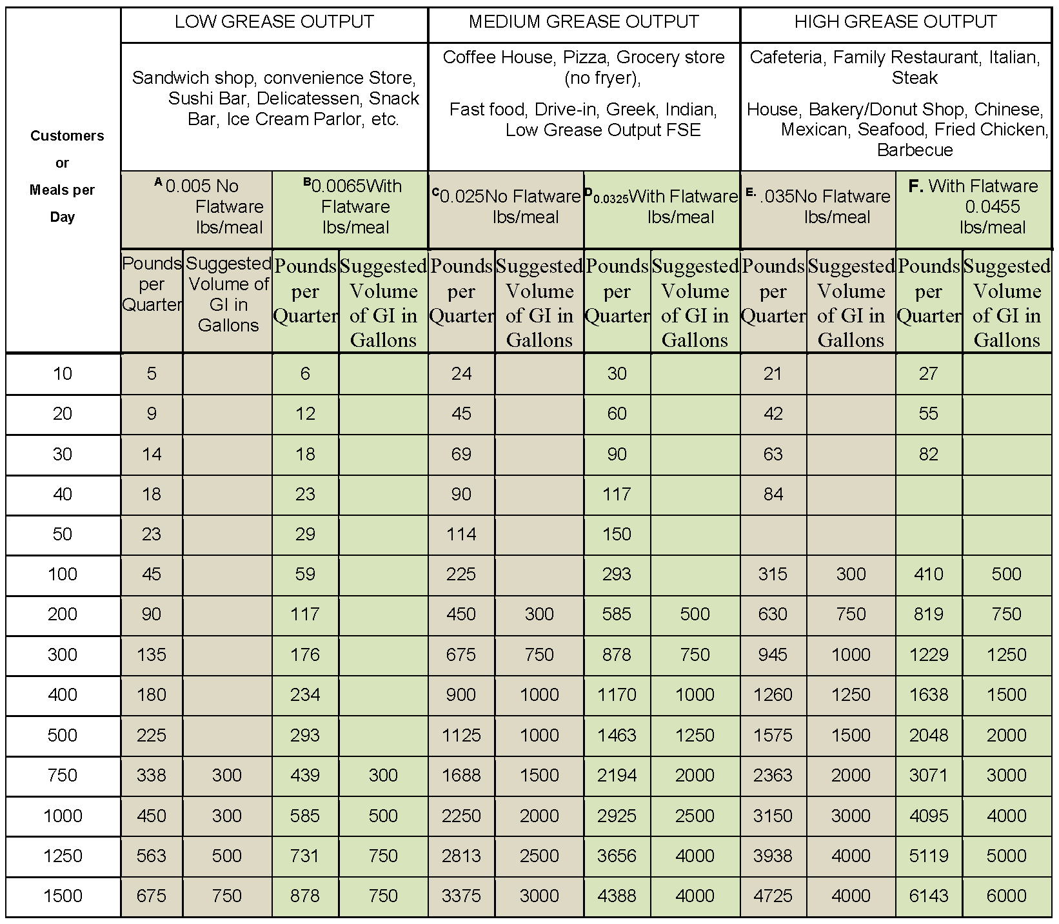
It should be noted that even using the "grease production" sizing method will not guarantee that a restaurant is on the correct cleaning frequency. That's why FOG Inspections are necessary, and why pumping frequencies may be changed if the interceptor proves to be too small to adequately maintain acceptable grease levels.
As previously stated, for establishing standardization throughout the city, no matter what the calculated capacity using the various formulas, the minimum interceptor size for the City of Senoia shall be 1,500 gallons, not to exceed a capacity of 3,000 gallons. Any additional capacity shall require the use of multiple interceptors. In addition, all indoor grease traps should hold a minimum of 70 pounds.
[Editorial Note: End of Deletion]
Grease Interceptor Maintenance
(a) Pumping. All grease interceptors shall be maintained by the user at the user's expense. Maintenance shall include the complete removal of all contents, including floating materials, wastewater, and bottom sludges and solids. Decanting or discharging of removed waste back into the interceptor from which the waste was removed or to any other grease interceptor, for the purpose of reducing the volume to be disposed, is strictly prohibited.
Failure to provide a completed manifest certifying that the interceptor has been pumped will result in a verbal warning or a written notice of violation. Continued failure to pump will be met with a $200.00 bill surcharge added to the offender’s water/sewer bill.
(1) Pumping frequency. Outdoor grease interceptors must be pumped out completely a minimum of once every three months. Under-sink or in-line grease interceptors must be pumped/cleaned out completely a minimum of once every 30-60 days as necessary. However, traps and interceptors may need to be pumped more frequently as needed to prevent carryover of grease into the sanitary sewer collection system. Pumping frequency may also be extended past the minimum period if it can be demonstrated by the user to be acceptable and approved by the City of Senoia.
(2) Pump out order. When the oil and grease concentrations exceed the City of Senoia's maximum discharge limits and/or the combined depth of bottom and top solids exceeds 33 25 percent of the total depth of the trap, the City of Senoia will issue a pump out order to the user. The user shall have seven days from receipt of the order to comply. Where an emergency exists, a written or verbal warning shall be given to the user, and the user will have 24 hours to comply. Pump out orders may also be issued when pumping frequencies are extended beyond required pumping schedules.
(3) Disposal of interceptor pumped material. All waste removed from each grease interceptor shall be recorded on a proper manifest form. Also, all waste removed from each grease interceptor must be disposed at a facility approved by the City of Senoia to receive such waste in accordance with the provisions of this program. In no way shall the pumped material be returned to any private or public portion of the sanitary sewer collection system.
a. Additives. Any additive(s) placed into the grease interceptor or the discharge line system on a constant, or scheduled basis shall be reported to the City of Senoia. Such additives shall include, but are not be limited to, commercially available bacteria or other additives designed to absorb, consume, or treat fats, oils, and grease. The use of additives shall in no way be considered as an alternative technology or a substitution for maintenance procedures required herein. The use of additives can be terminated permanently by a city official as needed.
b. Chemical treatment. Chemical treatments such as drain cleaners, enzymes, acids, and other chemicals designed to dissolve, purge, or remove grease shall not be allowed to enter the grease interceptor.
Administrative Requirements
(a) Initial data acquisition. All food service facilities will be asked to complete a data sheet to establish the grease interceptor database. Forms may be attained from the City of Senoia and a copy of the form may be found in appendix A of this document. The City of Senoia database will be updated with additional or modified information after each yearly inspection.
(b) Administrative fees. Initial FSE information forms must be completed and a receipt letter for this document must be signed. However, no fee will be charged for any quarterly or annual inspection by the City of Senoia.
(c) Inspection and entry. Authorized personnel of the City of Senoia, bearing proper credentials and identification, shall have the right to enter upon all properties subject to this program, at any time and without prior notification, for the purpose of inspection, observation, measurement, sampling, testing or record review, as part of this program.
(d) Record retention and reporting. All users must keep a record of any cleaning or maintenance of their grease interceptor. The following records must be kept on-site at the food service facility for a minimum of two years:
(1) Manifests. Required for all grease interceptors and shall contain the following:
a. Food service facility (generator) information, including name, address, volume pumped, date and time of pumping, and generator signature verifying the information;
b. Transporter information, including company name, address, license plate number, permit number, driver name, and driver signature verifying transporter information.
c. Receiving information, including facility name, address, date and time of receiving, EPD permit number, and signature verifying receipt of the waste.
d. Manifests are generally provided by the grease pumping company and once completed, must be mailed, faxed, or electronically submitted to the City of Senoia Public Works Department within 14 7 days of interceptor maintenance. This must be turned in before the last date of the clean-out cycle. Failure to provide proper paperwork will incur the $200 surcharge after the 7 days, failure to pay the fine within 7 days will result in a Code Enforcement visit.
e. A manifest may not be required for under-sink or inline grease interceptors, if user can demonstrate a valid reason not to use one. If approved, maintenance logs must be substituted for the pumping manifest. This log shall include the date, time, amount pumped or cleaned, hauler, disposal site, and signature. The log shall be kept in a conspicuous location for inspection and shall be made immediately available to the health officer or a City of Senoia representative upon request. See appendix B for an example maintenance log.
Enforcement
Enforcement of these regulations shall be in accordance with the provisions of the city's sewer use ordinance, and its industrial pretreatment regulations. Failure to comply with this program may result in notification to the city code enforcement or county health department to request enforcement actions that may lead to revocation of the food service permit and/or the city revoking the business license. The permit may be reissued by the City of Senoia upon remedy of the non-compliance that caused the suspensions, revocation or modification of the permit. Those authorized by the City of Senoia’s Sewer Department are allowed to fine up to $200 as a surcharge on the offender’s water/sewer bill. Sec. 70-109. High strength wastewater surcharge defines several parameters which qualify as high strength and thus will incur the surcharge. Those See the city's sewer use ordinance for additional enforcement actions, up to and including criminal prosecution, that may be used for enforcing this FOG ordinance.
- Enforcement Remedies Available to THE CITY OF SENOIA
The following list is arranged from least severe to most severe: Verbal Warning (VW) or Letter of Warning (LW)
  - Site Visit or Re-inspection (SV)
  - Notice of Violation (NOV)
  - Increased Self-monitoring or reporting (ISM)
  - Consent Orders (CO)
  - Show-cause Hearing (SCH)
  - Compliance Order or Schedule of Compliance (SOC)
  - Cease and Desist Order (CDO)
  - Administrative Fines (AF)
  - Emergency Suspensions (ES)
  - Termination of Discharge (TOD)
  - Water Supply Severance (WSS)
  - Judicial Enforcement Remedies or Litigation (LIT)

NONCOMPLIANCE | NATURE OF VIOLATION | RANGE OF RESPONSE
Record or Reporting Violation | Missing or incomplete Information | VW, LW, SV, NOV
 | Failure/Late to provide Required Reports | NOV, SCH, SOC, AF
 | Failure to Pump Interceptor at required  frequency | VW, LW, SV, NOV
 | Failure to Pump Interceptor after receiving Verbal Warning or NOV | $200.00 AF, CO, SCH, TOD, WSS
 | Falsification of records or manifests | CO, SCH, AF, TOD, WSS, LIT
Failure to Maintain Grease  Interceptor | Infrequent | VW, LW, SV, NOV
 | Frequent or Recurring | CO, SCH, AF, TOD, WSS, LIT
Improper Waste Disposal | Evidence of Intent (Dumping into sewer) | CO, SCH, AF, TOD, WSS, LIT
Compliance Schedules | Missed Milestone | VW, LW, SV, NOV
 | Failure to Install Required Equipment | CO, SCH, AF, TOD, WSS, LIT
 | Missed Final Date (90 days outstanding without  valid cause) | CO, SCH, AF, TOD, WSS, LIT
Failure to Mitigate Noncompliance or Cease Production | Failure to cease | CO, SCH, AF, TOD, WSS, LIT
Failure to Provide  Free access to Facility or Records | Initial Violation | VW, LW, SV, NOV
 | Recurring Violation | CO, SCH, AF, TOD, WSS, LIT

(Ord. No. 21-01 , § 1, 3-1-2021)
Editor's note(s)—Ord. No. 21-01 , § 1, adopted March 1, 2021, repealed the former § 70-101, and enacted a new § 70-101 as set out herein. The former § 70-101 pertained to similar subject matter and derived from Ord. No. 03-02, § 1(§ 21), adopted Aug. 18, 2003.

Sizing and Selecting Hydromechanical Grease Interceptors (HGI)
The following two-step sizing methodology for hydromechanical grease interceptors (HGIs) shall apply regardless whether the unit will be installed indoors or outdoors:

Step 1: Size by Flow Rate
The minimum flow rate for a passive HGI may be calculated by either using fixture volume or pipe diameter with either a one-minute or two-minute drainage period. Use a one-minute drainage period when the interceptor is installed within 20 feet of directly connected fixtures and/or has indirectly connected fixtures. Use a two-minute drainage period when the interceptor will be installed exterior to the building beyond 20 feet of the connected fixtures.

Fixture Volume Sizing
When the final configuration of kitchen fixtures in an establishment is known, use the following formula for sizing fixtures by volume with a 75% fill factor:

(# of compartments ×[L (inches)×W (inches)×H (inches)])
231 cubic inches per gallon X 0.75 = Fixture Capacity Gallons

Fixture Capacity Gallons x 1 = one-minute drainage period (GPM) Fixture Capacity Gallons x 0.5 = two-minute drainage period (GPM)

Example: three-compartment sink with each compartment being 18 x 24 x 12 inches (3 x [18” x 24” x 12”]) = 15,552 cubic inches (in3)
15,552 / 231 = 67.3 total fixture capacity gallons
67.3 x 0.75 = 50.4 fixture capacity after loading factor (75%)
50.4 x 1 = 50 GPM (using one-minute drainage period)
or
50.4 x 0.5 = 25 GPM (using two-minute drainage period

To determine the minimum required flow rate for the HGI, calculate the capacity of each fixture that will be connected, add the volumes together, and use the appropriate drainage period. An appropriate HGI must be certified to meet the minimum flow rate as calculated.

It is advisable to use a one-minute drainage period when the HGI will be installed in the kitchen area near the fixtures being serviced. It is essential to use a one-minute drainage period when indirectly connected fixtures are connected to the HGI. A two-minute retention time assumes only directly connected fixtures are routed to the HGI. A two-minute drainage period will negatively affect the total time for draining fixtures and is often a complaint of owners.

Pipe Diameter Sizing
When the final configuration of kitchen fixtures in an establishment is unknown or to allow for the addition of fixtures in the future, the minimum HGI volume may be determined by the diameter of the drainage pipe leading from the establishment according to Table 2:

Table 2
Pipe Size (inches) | Full-Pipe Flow (GPM)1 | One-minute drainage period (GPM) | Two-minute drainage period (GPM)
2 | 20 | 20 | 10
3 | 60 | 75 | 35
4 | 125 | 125 | 75
5 | 230 | 250 | 125
6 | 375 | 400 | 200
2. 1/4 inch per foot based on Manning's formula with friction factor N = 0.012

When using pipe diameter sizing and the HGI is installed inside the kitchen near the fixtures being serviced, it is advisable to use a one-minute drainage period to ensure the drainage time is not a nuisance. When installed in the kitchen near the fixtures being serviced and with an indirectly connected fixture, it is essential to use a one-minute drainage period. When installed exterior to the building, where the developed length of piping can be quite long, a two-minute drainage period will provide a satisfactory result in drainage times.

Step 2: Calculate Grease Capacity
Once the minimum flow rate has been established in Step 1, calculate the minimum grease storage capacity for the HGI required for the desired pump-out frequency as follows:
=
X
X

Grease Factor from Table 3

Meals or Customers per day

Days between pump-outs

Grease Capacity Required

To determine the correct grease factor, using Table 3, select the menu type (1 through 30), then the correct column (A through D) for whether there is a fryer and whether the establishment uses disposable or washable plates, glasses, knives, forks and spoons (flatware).

Table 3
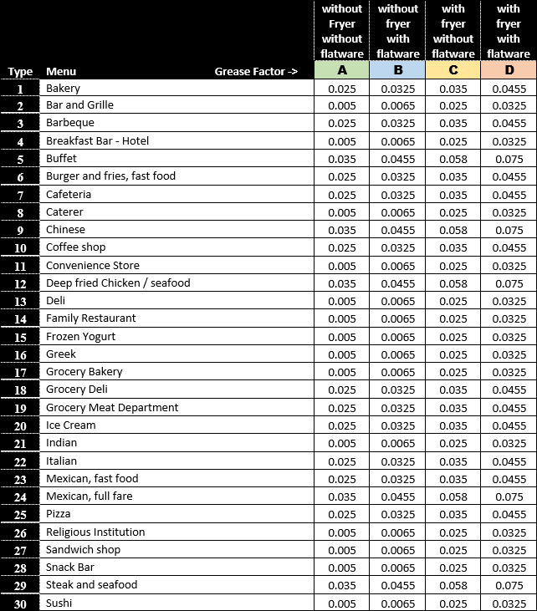

Example: Fast food burgers and fries, with fryer, with disposable flatware, serving 300 meals per day

Grease factor from Table 3: 6C = 0.035 pounds per meal Meals per day = 300
Days between pump-outs = 90
Grease storage capacity required is 0.035 x 300 x 90 = 945 pounds
For FSEs that only operate seasonally, the following shall apply:
1. During the season, the grease control device (GCD) shall be sized and maintained with the requirements of this document;
2. Prior to closing for the off-season, the GCD shall be pumped out completely, cleaned, and refilled with fresh water.
The correctly sized and selected GCD will have the minimum flow rate determined in Step 1 and the minimum grease storage capacity calculated in Step 2. When approved by the sanitary sewer system owner, multiple GCDs may be installed in series to satisfy the minimum flow rate requirement, the minimum grease storage capacity, or both.

Sizing and Selecting Car Wash Sand and Grease Interceptors
Hand Held Spray/Brush Wand | GPM | Interceptor Volume | May Use
Single Bay | 20 |  | 250
2 Bay | 32 |  | 350
3 Bay | 44 |  | 500
4 Bay | 56 |  | 750
5 Bay | 68 |  | 750
6 Bay | 80 |  | 1000
7 Bay | 92 |  | 1000
8 Bay | 104 |  | 1250
9 Bay | 116 |  | 1250
10 Bay | 128 |  | 1250
Automated Drive Through | GPM | Interceptor Volume | May Use
Single Bay | 40 | 480 | 500
2 Bay | 80 | 960 | 1000
3 Bay | 120 | 1440 | 1500
4 Bay | 160 | 1920 | 2000

Vehicle Storage and Servicing – Oil Separator and Sand/Gravel Separator

- In motor vehicle storage facilities, a combination separator-drain shall be installed with a static water level of 1 gallon for every 100 square feet of area to be drained.

- Where motor vehicles are serviced and stored, an oil separator shall be installed with a static water capacity of 1 cubic foot for every 100 square feet of area to be drained. The oil separator shall have a minimum static water level of 6 cubic feet.

- Where electric motor vehicles are serviced, stored or charged we shall follow the most current recommendations of the national plumber’s code.

