Memo

TO: Planning Commission
FROM: Curtis Hindman, Interim Community Development Director
DATE: September 19, 2023
RE: 27 Coweta Street
Rezone from R40 to RH
Located within Historic District

Background

The applicant requests to amend the zoning of the above referenced address from Residential (R-40) to Residential (RH).

R40 – Front – 40 feet, Side – 20 feet, and Rear -40 feet
RH – Front – 15 feet, Side – 20 feet, and Rear – 20 feet (as recently established)

The applicant asserts that rezoning to RH will allow the new house to meet the setbacks without a variance. The lot size 0.25 acres which does not meet the minimum lot size for RH but it is an existing lot of record.

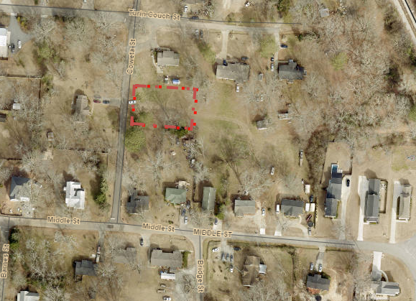

Zoned R40:

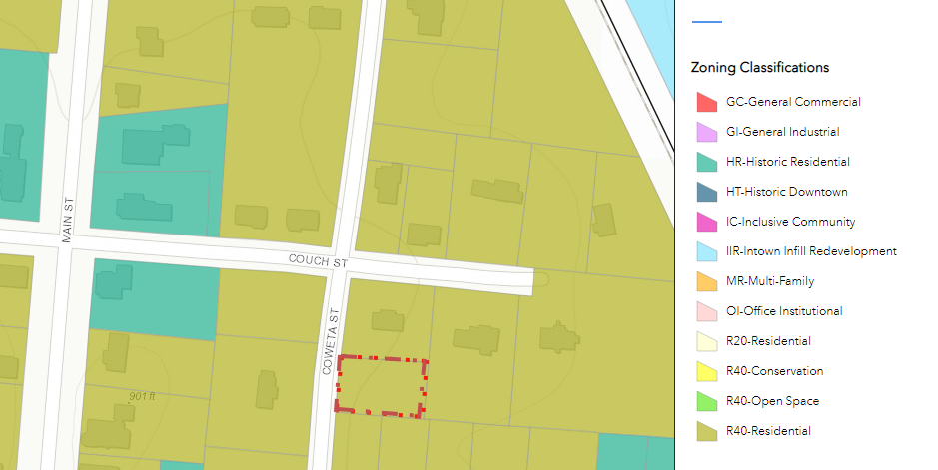

According to the Comprehensive Plan amended and adopted in 2021 this property has been shown in the “Future Land Use Plan” as Single Family Residential and within the Suburban Residential Character Area.

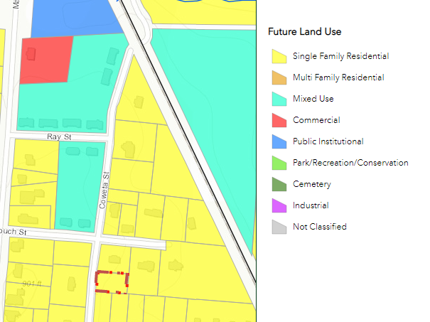

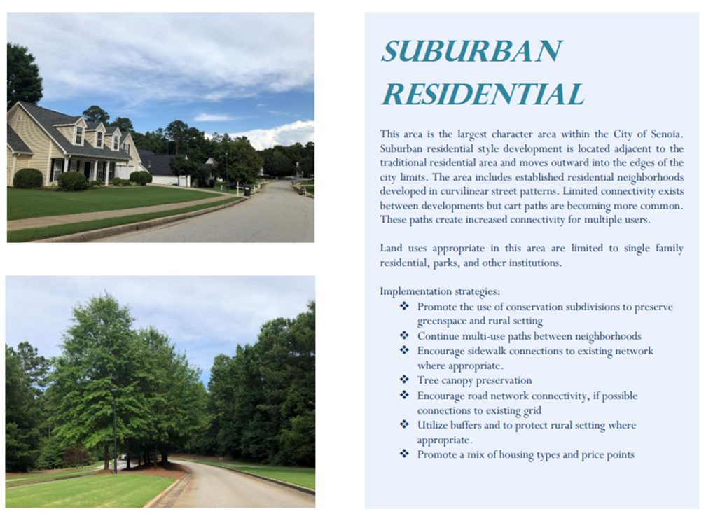

Administrator's Report

In consideration of the requested zoning change, the Planning Commission should consider the zoning ordinance, section 74-46, which lists the following twelve standards governing the exercise of the zoning power of the City of Senoia.

- The existing land uses and zoning classification of nearby property.
The subject property is currently zoned R40 and located within the city limits and lies within the historic downtown overlay district. The subject property is
surrounded by RH and R40 zoning.

- The suitability of the subject property for the zoned purpose.
The land is suitable for residential use as proposed. The current lot size does not meet the minimum lot size for RH.
- The extent to which the property values of the subject property are diminished by the zoning restrictions.
There is no reduction in value of the land due to the existing or proposed residential zoning.
- The relative gain to the public, as compared to the hardship imposed upon the individual property owner.
The application represents no gain to the public. There is a recognized hardship for the property owner if not rezoned due to the size of the lot and the setbacks of R40.
- Whether the subject property has a reasonable economic use as currently zoned.
The subject property does not have a reasonable economic use for residential as currently zoned due to the lot size and setbacks.
- Whether the proposed zoning will be a use that is suitable in view of the use
and development of adjacent and nearby property.
The proposed zoning and use as residential are both suitable and similar to the existing uses adjacent to the subject property.
- Whether the zoning proposal will adversely affect the existing use or usability of adjacent or nearby property.
The zoning of RH will not negatively impact the adjacent properties existing use or usability. The setbacks in RH are smaller than in R40 but remain adequate for the intended use and lot size.
The ordinance allows a rear setback of zero and staff recommend that a minimum rear setback of 20 feet be imposed as a condition of the rezoning request.
- Whether the zoning proposal is in conformity with the policies and intent of the land use element of the Comprehensive Plan.
The future character map shows this property as Residential.
- Whether the zoning proposal will result in a use, which will or could cause excessive or burdensome use of existing streets, transportation facilities, utilities, or schools.
There is no excessive use or burden to streets, transportation facilities, utilities or schools recognized by approving this application.
- Whether there are other existing or changing conditions affecting the use and development of the property, which give supporting grounds for either approval or disapproval of the zoning proposal.
There is none.
- Whether the subject property contains jurisdictional wetlands of the United States. If so, the applicant will be required to document permit approval for the proposed development from the U.S. Army Corps of Engineers before any formal action can be taken on the zoning proposal.
There is none.
- Whether the subject property may be large enough to qualify as a Development of Regional Impact. If so, then an application for Review must be filed with the Regional Development Center.
The development is not big enough to qualify.

Action by Planning Commission

The planning commission may recommend approval or denial of the application or may recommend changes to the applicants request which would reduce the land for which the application is made, change the district from that requested to another district, or recommend conditions of zoning which may be deemed advisable so that the purpose of the ordinance is served, and the health, public safety and general welfare of the City of Senoia is secured.

The Planning Commission must make a recommendation to the City Council within 30 days of the public hearing.

